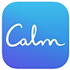Calm
Calm is a leading app for meditation and sleep. Join the millions experiencing lower stress, less anxiety, and more restful sleep with our guided meditations, Sleep Stories, breathing programs, masterclasses, and relaxing music. Recommended by top psychologists, therapists, and mental health experts.
iOS; Android
​​
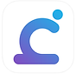Calm Harm
Calm Harm provides tasks that help you resist or manage the urge to self harm. You can add your own tasks too and it’s completely private and password protected.
iOS; Android​​
​
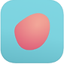Cove: Music for Mental Health
Expressing your emotions can be hard. It can be easier if you make music! Cove is trusted by doctors and therapists as a safe and secure way to look after your mental health.
iOS
​
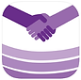The Daily Difference
This app helps teens who are dealing with mental health issues including mild anxiety, depression, self harm, and bullying. If a teen is in need of step by step help on dealing with symptoms of any of these, there are help modules to help guide them through these situations. Users can also add journal entries to keep track of their thoughts and processes and there is also a private chat function that users can use to communicate with qualified health care professionals.
iOS; Android​
​
DiveThru
DiveThru is a guided journaling app that helps you DiveThru what you go thru. We work with mental health professionals to create guided journaling exercises that help you take charge of your mental health.
iOS; Android​
​
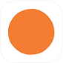Headspace: Meditation & Sleep
Get happy. Stress less. Sleep soundly. Headspace is your guide to mindfulness for your everyday life.
iOS; Android​
​
Lyf – You’re Not Alone
Lyf App is a platform to share thoughts and experiences that might be too personal for your other social medias. Whether you’re battling anxiety, dealing with infidelity, coping with loss, struggling with addiction, or questioning your sexual identity, there are others going through the same thing. With Lyf you’re provided a world of support in the palm of your hand.
iOS; Android​
​
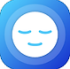MindShift CBT
Is anxiety getting in the way of your life? MindShift uses scientifically proven strategies based on Cognitive Behavioural Therapy (CBT) to help you learn to relax and be mindful, develop more effective ways of thinking, and use active steps to take charge of your anxiety.
iOS; Android
​
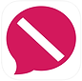notOK
notOK is a digital panic button service to get you immediate support via text, phone call, or GPS location when you’re struggling to reach out.
iOS; Android​
​
​
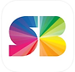SuperBetter
Resilience training. Powered by the science of games.
Join nearly a million people who have played SuperBetter so far to build resilience, achieve goals, and tackle challenges including anxiety, depression, stress, chronic pain, concussion recovery and more.
iOS; Android​
​
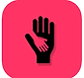What’s Up – A Mental Health App
What's Up? is a fantastic free app utilising some of the best CBT (Cognitive Behavioural Therapy) and ACT (Acceptance Commitment Therapy) methods to help you cope with Depression, Anxiety, Anger, Stress and more!
iOS; Android

